MS Teams – basic tutorial

Learning Material

This document is a compilation of quick user tips for Microsoft Teams

Table of Contents

Manage your call settings in Teams 2

Change your default mic, speaker, or camera 2

Set your call answering rules 2

Adjust your voicemail settings 2

Voicemail greeting 3

Call answer rules 3

Default greeting language 3

Text-to-speech voicemail greeting 3

Out of office voicemail greeting 4

Choose ringtones 4

Turn on Text Telephone (TTY) 4

Manage blocked numbers 4

Manage call queue notifications 5

Start a call from a chat in Teams 6

Use the dial pad to make a call 7

Answer a call in Teams 9

Add someone to a call in Teams 10

Make multiple calls at the same time in Teams 11

Put a call on hold in Teams 11

Transfer a call in Teams 12

Consult then transfer 12

Park a call in Teams 13

# Manage your call settings in Teams

To change your settings, select **Settings and more** Select to see more options  next to your profile picture at the top of Teams and then choose **Settings**.

There are a few different places with call settings: **General**, **Devices**, and **Calls**.

**Note:** If you don't see **Calls** Calls button on the left side of Teams, talk to your IT admin.

# Change your default mic, speaker, or camera

To select the mic, speaker, and camera you want Teams to use for calls and meetings, select **Settings and more** Select to see more options  next to your profile picture at the top of Teams and then choose **Settings**> **Devices**.

Under **Audio devices**, pick the speaker and mic you want Teams to use by default.

Under **Camera**, select the camera you want Teams to use, and see a preview of that camera's video.

If you have multiple certified devices connected to your computer, you can set one as your **secondary ringer**, which means it'll ring when a call comes in. Answer incoming calls on any device—not just the ones that ring.

# Set your call answering rules

To set your call answering rules, select **Settings and more** Select to see more options  next to your profile picture at the top of Teams and then choose **Settings**> **Calls**.

Choose how you want Teams to handle your incoming calls in the section for **Call answering rules**.

Select **Forward my calls** if that's what you want to do. If you want simultaneous ring, click **Calls ring me** and select others under**Also ring**.

Choose what to do with calls that go unanswered under **If unanswered**.

# Adjust your voicemail settings

To change your voicemail settings, select **Settings and more** Select to see more options  next to your profile picture at the top of Teams and then choose **Settings**> **Calls**.

In the **Voicemail**section, click **Configure voicemail**. That's where you'll find all your voicemail settings.

# Voicemail greeting

To record a new voicemail greeting, select **Record a greeting** and follow the instructions to record your message.

# Call answer rules

To change how calls are handled once they reach your voicemail, go to **Call answer rules**. By default, Teams will play your voicemail greeting and allow the caller to record a message. You have some other options, though:

Let the caller record a message.

Let the caller record a message or be transferred to someone else.

End the call without playing your greeting.

Play your greeting and end the call.

Transfer the call to someone else.

If you choose an option that includes transferring the call, set the name or number where you want your calls to go under **Where should they be transferred?**

# Default greeting language

Change your default greeting language by selecting the language you want under Greeting language.

# Text-to-speech voicemail greeting

To use a text-to-speech voicemail greeting, type one in **Your custom greeting** under **Text-to-speech customized greeting**.

**Note:** If you've recorded a greeting, it'll override the text-to-speech option.

# Out of office voicemail greeting

Type your out of office greeting in **Your custom out of office greeting** under **Text-to-speech customized greeting**, then choose when you'd like it to play under **Out of office greeting**.

# Choose ringtones

To set your preferred ringtones, select **Settings and more** Select to see more options  next to your profile picture at the top of Teams and then choose **Settings**> **Calls**.

There, under **Ringtones**, you can choose separate ringtones for your normal calls, forwarded calls, and delegated calls so you're able to tell them apart.

# Turn on Text Telephone (TTY)

Select **Settings and more** Select to see more options  next to your profile picture at the top of Teams and then choose **Settings**> **Calls**.

In the **Accessibility**section, click **Turn on TTY mode**.

# Manage blocked numbers

To view and manage the numbers you've blocked, select **Settings and more** Select to see more options  next to your profile picture at the top of Teams and then choose **Settings**> **Privacy**.

Select **Edit blocked contacts**under **Blocked contacts**to see any numbers you've blocked and remove them from the list.

To block anonymous calls, select **Block calls with no caller ID**.

# Manage call queue notifications

If you're a call queue agent, you can turn notifications off or on for each of your queues.

Go to **Settings**> **Calls**, and scroll down to **Call queues** to see a list of your queues. Click the toggle switch next to each queue to turn notifications on or off.

# Start a call from a chat in Teams

You can make one-on-one or group calls with anyone in your organization directly from a chat without having to host a team meeting. These calls are private and won't appear in any team conversation. Entries for the calls will appear in your chat, though.

1. Go to your chat list, and click **New chat** New chat button to start a new conversation.
2. Type the name or names into the **To** field at the top of your new chat.
3. Select **Video call** Video call button or **Audio call** Calls button to start a call.

Up to 20 people can be on the same video call.

**Note:** If a group chat includes more than 20 people, calling buttons will be disabled.

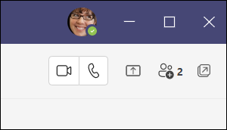

If you're not currently in a chat with the person you want to call, you can start a new call from a command. Go to the command box at the top of your screen and type **/call**, then type or select the name of the person you want to reach.

You can also start a one-on-one call from someone's profile card. Open it by clicking their picture in a channel or from a search.

**Note:** If your organization is set up for it, you can [call a phone number directly](https://support.microsoft.com/en-us/office/use-the-dial-pad-to-make-a-call-20d24ace-2851-4c29-8441-30dd2a5cf078)—evenone that's outside your org.

# Use the dial pad to make a call

The dial pad can be used like a typical phone to make a call to a phone number. (You can also type in names or groups.)

To dial a number from Teams, go to **Calls** Calls button , and then enter the number of the person you want to reach by using the dial pad located on the left. Then click **Call** Calls button .

To call a person by name, type the name of a person into the dial pad. And to make group calls, enter multiple names and/or numbers, and click **Call** Calls button .

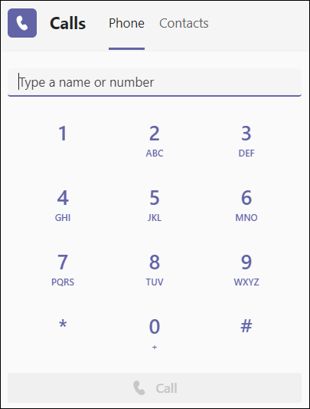

To access your dial pad during a call, go to your call controls and select **Dial pad** Dial pad button .

You can also check out the [First things to know about calls in Microsoft Teams](https://support.microsoft.com/en-us/office/first-things-to-know-about-calls-in-microsoft-teams-2b883a81-dd15-41bd-a6ba-39deef141027) article for more calling options and features.

**Important:** You won't be able to make a 911 emergency call if Teams isn't connected to the internet.

**Note:** If you don't see the option to dial a number, your org may not have purchased a [calling plan](https://docs.microsoft.com/en-us/MicrosoftTeams/calling-plans-for-office-365). But you can still make calls to other people in Teams.

# Answer a call in Teams

When someone calls you, you'll get a notification that lets you accept or decline the call.



* Select **Accept with audio**Calls button to answer with audio only.
* Select **Accept with video** Video call button to accept the call and enable video as well.
* Select **Decline call** red phone to decline the call and go on with your day.

# Add someone to a call in Teams

When you're already on a call, you might want to add someone new and create a group call.

To add someone new to a group call, select **Show participants** Add team icon. in your call controls, then type their name or phone number in the search box.

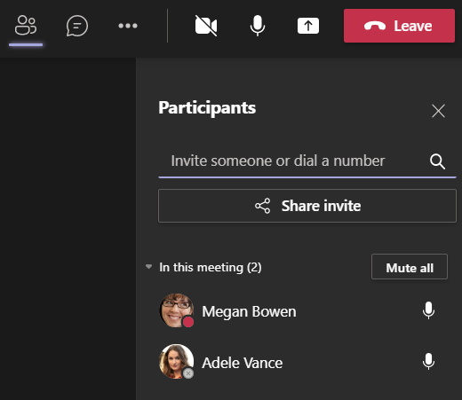

# Make multiple calls at the same time in Teams

If you're already on a call, you can [answer](https://support.microsoft.com/en-us/office/answer-a-call-in-teams-780c6946-2061-4efc-82c3-336aabfc7da0) or [start a new call](https://support.microsoft.com/en-us/office/start-a-call-from-a-chat-in-teams-f5138c9d-df4c-43d8-9cf6-53400c1a7798) anytime. We'll place your current call on hold and take you straight to your new conversation.

While a call’s on hold, all participants will be notified, and they won't be able to see or hear you. You'll see your on-hold calls displayed on the left side of your call window, so you can get back to them a

# Put a call on hold in Teams

To place a call on hold, click **More actions** More options button in your call window and select **Hold**.

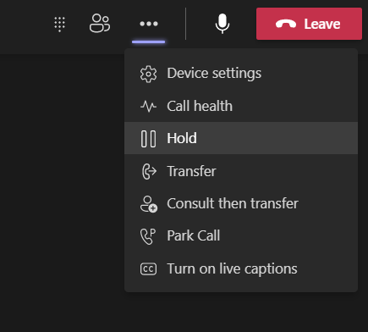

Everyone in the call will be notified that they've been put on hold, and you can continue your call by clicking **Resume**.

People on hold (including you) won't be able to see or hear anyone else on the call. Screen sharing is temporarily suspended, too. Everything will return to normal once you resume your call.

Anyone who's on a PSTN line will hear music when they're put on hold.

# Transfer a call in Teams

To transfer a call:

1. Choose More actions  Select to see more options > Transfer in your call controls.
2. Start typing the name of the person you want to transfer the call to and select them when they appear.
3. If they're in your org and using Teams or Skype for Business, you can turn on Ring back if there's no answer. This will send the call back to you if the recipient doesn't answer.
4. To finish, hit Transfer again.

For more transfer options, click the drop-down arrow in the Transfer button. Choose Work to transfer the call to their Teams number, or Work voicemail to send it straight to their voicemail. If they've added any other phone numbers to their account, like their mobile number, you'll see those options in the list, too.

Just keep in mind you can only transfer calls when you're talking one-on-one.

# Consult then transfer

If you want to check in with someone before you transfer a call to them, follow these steps:

1. When you're in a call, select More actions  More options button > Consult then transfer.
2. Under Choose a person to consult, start typing the name of the person you want to reach and select them when they appear. You can call them, or consult with them over chat.
3. When you're ready, hit Transfer.

# Park a call in Teams

To place a call on hold on one device and pick it up from another device, also known as *parking a call*, click **More actions** More options button in your call window and select **Call park** Call park .

After you park the call, Teams will give you a unique code you can use to retrieve the call. If someone else is retrieving the call, copy the code and share it with them.

To retrieve a parked call, go to the speed dial tab, click **Unpark** Call park , and enter the park code.

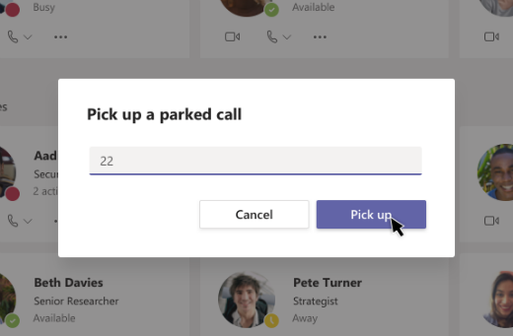

If no one picks up a parked call within 5 minutes, it’ll ring again.